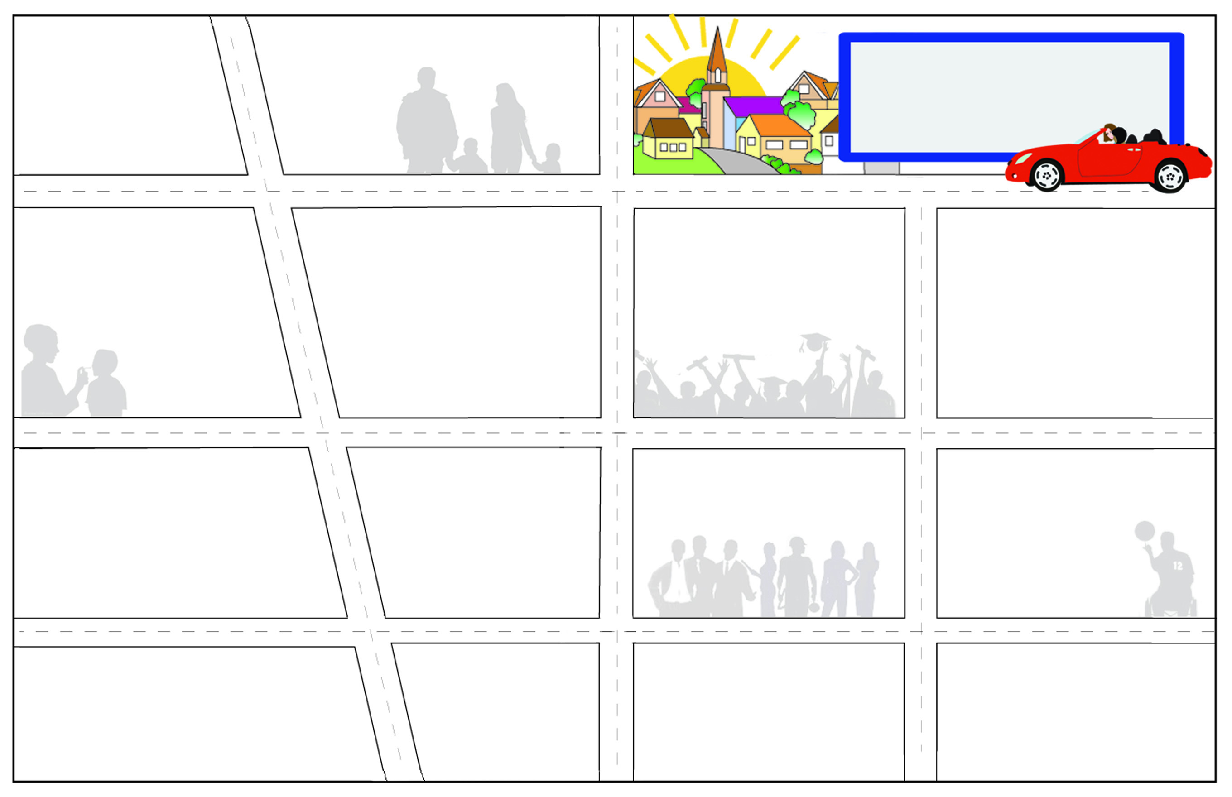

Health Care Coverage/Benefits Counselors: Contact the ADRC or CYSHCN Regional Center

Medicaid and private insurance can help pay for needed medical care and services, (including therapies, medication, equipment.) Medicaid programs include BadgerCare Plus, Katie Beckett/CompassWisconsin Threshold (until age 19), SSI, SSDI, HIRSP, MAPP and Waivers. It is important to understand options, eligibility and what is covered.
Recreation/Social Opportunities: Special Olympics of Wisconsin: 1-800-552-1324
Recreation can play an important role in a youth’s or young adult’s life. A variety of organizations provide recreational activities in your community; some with a disability focus.

Education after High School:
Contact the ADRC or CYSHCN Regional Center

Postsecondary education includes many kinds of education and training programs, including: technical college degree and certification programs, apprenticeships, two and four-year colleges, private trade school, non-degree programs and on-the-job training. Contact universities, colleges or technical colleges directly.
Information and Assistance:
Aging and Disability Resource Center (ADRC): 920-647-8734 or
1-866-740-2372
The ADRC can assist families in learning about options when turning 18.
At age 17 1/2 the ADRC staff will assess eligibility and provide information on long term supports for young adults/adults and make appropriate referrals to programs or service agencies.

Special Education:
DPI: 1-800-441-4563
WI FACETS: 1-877-374-4677

Transition planning begins at age 14. The IEP
(Individual Education Program) team helps students identify goals for work, education and independent living after high school, as well as the people and activities that will help meet these goals. Person-centered planning is a way to identify and youth’s individual goals and to help youth, families and professionals craft plans that will support youth as they strive to achieve their dreams.

Supplemental Security Income (SSI): 1-800-772-1213

SSI provides Medicaid as well as a monthly financial benefit to children and adults with a disability who meet income and assets eligibility guidelines. At age 18, parent income & assets are no longer considered. An application can be made to SSI in the month a youth turns 18.
Guardianship & Legal Decision-Making at age 18:
Contact the ADRC or CYSHCN Regional Center

When youth with disabilities turn 18 they have all the legal rights and responsibilities of adults. They can vote, get married, make a contract, give or refuse consent for medical treatment and make decisions independently. There are legal options for decision making which include: guardianship, powers of attorney and others.

Employment:
Division of Vocational Rehabilitation (DVR) – 1-800-422-7138

Employment includes many kinds of choices from workshops, part time jobs to full-time careers, with or without support of outside agencies. The Division of Vocational Rehabilitation is a federal program which helps those with disabilities obtain gainful employment.
Transportation:
LogistiCare: 866-907-1493

Transportation can be accessed through your county’s transportation system. Wisconsin uses LogistiCare for all nonemergency medical transport. Depending on the type of transportation provided there may or may not be a cost to you.

Information and Assistance:
Southeast Regional Center for Children and Youth with Special Health Care Needs ( CYSHCN): 1-800-234-5437

The Regional Center is a place to call with questions about a wide range of topics including transition, employment, housing options, community supports and connections to other youth or parents. They can answer questions and help you with pre-transition planning before turning 18.

2012
Welcome To Jefferson County
Resource Roadmap for Transition
A map to services for youth with special health care
needs or disability, age 14 to adulthood.

County Human Services Programs: 920-674-8715
Human Services provides access to long term supports and services for eligible children and adults experiencing cognitive, physical and emotional disabilities. Programs include case management, respite, Family Support, Children’s Waivers and other in home, after school and out of home supports.
Public Health Department:
920-674-7275

Public Health Nurses can be a partner in providing access to local service coordination and long term care program supports. Public Health services may include the Personal Care Program, home visiting, physicals or exams, and immunizations clinics (including flu shot & pneumonia shots).

Mental Health Services:
920-674-3105

Mental Health Program s provides services to people who have a severe and persistent mental health issues of an acute nature.

Support at Home and in the Community:
Family Care/IRIS/Partnership: Contact the ADRC
Wisconsin offers an array of community-based long-term support for youth and adults with disabilities. These supports are designed to help individuals meet their goals for work, independent living and community participation.
Eligibility is based on income and the impact of
disability on a person’s ability to function in his/her daily life.
Resource Roadmap for Jefferson County is supported by the Southern Regional Center for CYSHCN & Jefferson Co. Transition Network. Concept originally developed by the FOR U staff at the Chippewa County Health Department.
For additional copies contact the Aging and Disability Resource Center 1-866-740-2372 or download the document at www.jeffersoncountywi.gov

Statewide Resources
ABC for Health, Inc.: nonprofit public interest law firm dedicated to ensuring health care access for children with special needs
www.safetyweb.org 1-800-585-4222
(ADRC) Aging Disability and Resource Centers: provides information, supports and connection to services for adults with disabilities
www.dhs.wisconsin.gov/LTCare/adrc 1-866-740-2372
(CAP) Client Assistance Program- information and assistance to individuals who have a dispute with DVR
http://dwd.wisconsin.gov/dvr/cap.htm 1-800-362-1290
(DRW) Disability Rights Wisconsin: provides protection and advocacy for persons with disabilities in Wisconsin
www.disabilityrightswi.org/ 1-800-928-8778
(DPI) Wisconsin Department of Public Instruction: Special Education Team: information on public education for youth with disabilities
http://dpi.state.wi.us/sped/tm-specedtopics.html 1-800-441-4563
(DVR) Wisconsin Division of Vocational Rehabilitation: state employment training program for individuals with disabilities
http://dwd.wisconsin.gov/dvr/ 1-800-442-7138
(FACETS) Wisconsin Family Assistance Center for Education, Training and Support: provides free information and assistance
to families concerning parent and student rights and opportunities in education
www.wifacets.org/ 1-877-374-4677
Family Support Program: provides information about services and resources, funding and linkage with other families
www.dhs.wisconsin.gov/bdds/fsp/index.htm 1-800-642-7837
Family Voices of Wisconsin: grass roots training, information, advocacy network of families with focus on policy & budget www.fvofwi.org
(ILCs) Wisconsin Independent Living Centers: consumer-driven services to promote full participation in society of persons with
disabilities. Services include: health benefits counseling, assistive technology, peer support and advocacy
http://dhs.wisconsin.gov/disabilities/Physical/ILCs.htm 1-800-362-1290
Legal Action of Wisconsin: non-profit agency providing legal representation to low-income people and others
www.legalaction.org 1-800-362-3904
(NAMI) National Alliance on Mental Illness: provides crucial information to persons affected by mental illness
http://www.namiwisconsin.org/ 1-800-236-2988
Parent to Parent of Wisconsin: provides one-to-one connection with another parent who has similar experience and who knows
firsthand about the feelings and realities that come with having a child with special needs
www.p2pwi.org/ 1-888-266-0028
(SSI) Supplemental Security Income: financial benefits (including SSI, SSDI) for youth meeting income and asset eligibility criteria
www.ssa.gov 1-800-772-1213
WisTECH: provides information on selecting, funding, installing and using assistive technology
http://dhs.wisconsin.gov/disabilities/wistech/ 1-608-267-9091
Wisconsin Council of the Blind & Visually Impaired: services, advocating legislation and educating the general public
www.wcblind.org/ 1-800-783-5213
Wisconsin Family Ties: network of Family Advocates who provide support groups, peer-mentoring, training, advocacy, information and referral for families that include children and youth with mental, emotional, behavioral or substance abuse disorders
www.wifamilyties.org/ 1-800-422-7145
Wisconsin First STEP: 24-hour information and referral service to assist Wisconsin families who have children with special needs
www.mch-hotlines.org 1-800-642-7837
Wisconsin Regional Centers for Children and Youth with Special Health Care Needs (CYSHCN) - a network of information and assistance services for families of children /youth ages 0-21with disabilities or special health care needs www.dhs.wisconsin.gov/health/children/resourcecenters 1-800-532-3321
(WSPEI) Wisconsin Statewide Parent Educator Initiative: parent liaisons that work with families, educators and school districts
through the CESA’s to promote positive partnership and free consultation to families of children with special educational needs
http://dpi.wi.gov/sped/parent.html 1-877-844-4925

(WSTI) Wisconsin Statewide Transition Initiative
www.wsti.org/ 1-715-986-2020 ext. 2122

HEALTH COVERAGE
ACCESS: online tool to apply for help through Wisconsin's health, nutrition and other programs https://access.wisconsin.gov/access/
Managed Care Ombudsman: investigates and resolves problems, provides information, referral and consultation and works with licensing, certification, and other enforcement agencies to improve the quality of care in long term programs
http://dhs.wisconsin.gov/aging/boaltc/ltcombud.htm 1-800-815-0015
Medicaid (Medical Assistance, M.A., Title 19, BadgerCare Plus, Katie Beckett, SSI, MAPP, HealthCheck) Recipient Hotline:
information about eligibility, rights, covered benefits, providers, problems with bills, etc. for those with Medicaid 1-800-362-3002
HIRSP: Wisconsin’s high-risk health insurance pool www.hirsp.org/ 1-800-828-4777
Information and Assistance:
ADRC 920-674-8734
SE Regional Center for CYSHCN 1-800-234-5437
Wisconsin First Step 1-800-642-7837
Society’s Assets Inc……………………………………………………………1-800-378-9128
211/First Call for Help……………………………………………211 or 1-262-547-3388

County Government Resources:
Civil Rights…………………………………………………………………………1-608-266-3465
Wisconsin Board for People with Dev. Disabilities…………….1-888-332-1677
Independent Living Council (ILCW)……………………………………1-866-656-4010
CompassWisconsin: Threshold………………………………………….1-608-263-7861

Day Services/Residential Services:
ADRC of Jefferson County……………………………………………….1-866-740-2372

Economic Support:
Jefferson Co. Workforce Development Center………………1-888-794-5780

Education after High School:
Madison Area Technical College (Madison College) 1-800-322-6282
UW Whitewater 1-262-472-1234
UW Whitewater (Center Students with Disabilities)…………1-262-472-4711
Madison College Disability Resource Services…………………..1-608-246-6716
High School Guidance Counselor………………

Employment:
Division of Vocational Rehabilitation………………………………….920-675-4629
Opportunities Inc…………………………………………………………….1-800-314-4567
Pantheon Industries………………………………………………………..1-262-569-5515
St. Coletta Access Program…………………………………………………920-674-8225
WorkSmart’s Young Adult Program…………………………………1-608-242-4564

Envisioning the Future:
Dept. of Public Instruction Opening Doors Series:
(Post-secondary education, Self Determination, Employment)
www.dpi.state.wi.us/sped/pdf/tranopndrs.pdf
www.dpi.wi.gov/sped/pdf/tranopndrs-self-determination.pdf
www.dpi.state.wi.us/sped/pdf/tranopndrs-employmt.pdf

Financial Planning:
Aging and Disability Resource Center (ADRC)…………1-866-740-2372
Southeast Regional Center for CYSHCN………………….1-800-234-5437

Health Care:
Coverage/ Insurance:
HIRSP- Health Insurance Risk Sharing Plan 1-800-828-4777
Medicaid:
Katie Beckett 1-608-265-4102
Badger Care https://access.wisconsin.gov
MAPP-Medicaid Purchase Plan 1-800-362-3002
SSI-Supplemental Security Income 1-800-772-1213
(Possible Medicare Eligibility)

Support at Home and in the Community:
Family Care http://dhs.wi.gov/ltcare/
IRIS http://dhs.wi.gov/bdds/IRIS/index.htm
Partnership http://dhs.wisconsin.gov/wipartnership/
CIP http://dhs.wisconsin.gov/bdds/cip/index.htm

Learning/ Leadership Opportunities:
For Youth:
Wisconsin Youth First: www.wiyouthfirst.org
Peer Power: 1-608-256-9257
Youth in Partnership with Parents for Empowerment…1-800-862-3725
CESA #2……………………………………………………………………….1-262-473-1473
For Parents:
Family Voices DYK Trainings……………………………………….1-608-233-3726
Wisconsin Statewide Transition Initiative (WSTI)……….1-262-473-1473
Youth in Partnership with Parents for Empowerment..1-800-862-3725
Wisconsin Family Ties (Parents Only)………………………….1-800-422-7145
For additional opportunities for both youth and parents: URL
Guardianship - Legal Decision Making at age 18:
On turning 18 booklet:
www.legalexplorer.com/resources/database/PubPDFs/54-ONB18.pdf
Wisconsin Guardianship Support Center 1-800-488-2596
ADRC of Jefferson County…………………………………………...1-866-740-2372

Mental Health Resources:
Wisconsin Family Ties………………………………………………..1-608-267-6888
Jefferson Co. Human Services……………………………………………...674-3105
Recreation/ Social Opportunities:
Special Olympics SE Region 7……………………………………..1-800-924-4320
Southeast Regional Center for CYSHCN……………………..1-800-234-5437
First Call for Help………………………………………………………….920-563-9555

Special Education:
CESA #2……………………………………………………………………….1-262-473-1473
WI Statewide Parent-Educator Initiative (WSPEI)………..1-877-844-4925
Contact your local school district………….

Transportation:
LogistiCare- for those with Medicaid or BadgerCare Plus
1-866-907-1493
Jefferson Co. Transportation …………………………………………………674-8104

Other Community Resources:
Catholic Charities-Diocese of Madison ………………………..1-608-833-4800

Support Groups:
Contact your area hospital/health services……………..

Jefferson County Resources

The Wisconsin Division of Public Health, Children and Youth with Special Health Care Needs (CYSHCN) Program provides consultation and technical assistance to the five Regional CYSHCN Centers and Wisconsin First Step. Funding is provided by a Maternal and Child Health Title V Service Grant, Maternal and Child Health Bureau, and the Health Resources and Service Administration, US Department of Health and Human Services..

